Teacher Notes for “Mitosis and the Cell Cycle
– How the Trillions of Cells in a Human Body Developed from a Single Cell”

In this minds-on analysis and discussion activity, students learn how the cell cycle produces genetically identical daughter cells. They analyze how DNA replication and mitosis work together to ensure that each new cell gets a complete set of chromosomes with a complete set of genes. To understand how a single cell (the fertilized egg) can develop into the trillions of cells in a human body, students analyze an exponential growth model for the increase in number of cells. The final section provides a brief introduction to cellular differentiation.

This activity can be used as an introduction to mitosis or to reinforce understanding of mitosis. A hands-on version of this activity is available as “Mitosis and the Cell Cycle – How a Single Cell Develops into the Trillions of Cells in a Human Body” (https://serendipstudio.org/exchange/waldron/mitosis).

Before beginning this activity, students should know what a cell is and have a basic understanding of the functions of DNA and proteins (e.g. using "Understanding the Functions of Proteins and DNA"; https://serendipstudio.org/exchange/bioactivities/proteins).

Learning Goals
In accord with the Next Generation Science Standards:
      - Students will gain understanding of the following Disciplinary Core Ideas:
- LS1.B: "Growth and Development of Organisms –In multicellular organisms individual cells grow and then divide by a process called mitosis, thereby allowing the organism to grow. The organism begins as a single cell (fertilized egg) that divides successively to produce many cells, with each parent cell passing identical genetic material (two variants of each chromosome pair) to both daughter cells. Cellular division and differentiation produce and maintain a complex organism, composed of systems of tissues and organs that work together to meet the needs of the whole organism."
- Students will engage in the Scientific Practices:
- “Developing and Using Models – Develop, revise, and/or use a model (including mathematical and computational) to generate data to support explanations, predict phenomena, analyze systems, and/or solve problems."
- “Constructing Explanations – Apply scientific ideas, principles and/or evidence to provide an explanation of phenomena…".
- This activity provides the opportunity to discuss the Crosscutting Concepts
- "Systems and system models – … Models can be valuable in predicting a system’s behaviors…"
- This activity helps to prepare students for the Performance Expectations:
- HS-LS1-4, "Use a model to illustrate the role of cellular division (mitosis) and differentiation in producing and maintaining complex organisms."
More Detailed Content Learning Goals
- The cell cycle includes growth of the cytoplasm, DNA replication, mitosis and cytokinesis. DNA replication and mitosis ensure that each daughter cell receives a complete copy of the DNA in the parent cell. The cell cycle produces new cells for growth and repair.
- At the beginning of mitosis, the two copies of the DNA in each chromosome are condensed into compact sister chromatids which are attached at a centromere. During mitosis, spindle fibers line up the chromosomes in the middle of the cell and then separate the sister chromatids of each chromosome, resulting in two complete sets of chromosomes at opposite ends of the cell.
- At the end of mitosis, cytokinesis separates the two halves of the cell to form two genetically identical daughter cells.
- An exponential growth model illustrates how the number of cells can increase from a single-cell zygote to roughly a trillion cells in a newborn baby. If each cell divided each day, the number of cells would double each day; after 40 days, this would produce a trillion cells.
- Cell differentiation produces the many different cell types in a baby’s body. During differentiation of each type of cell, specific genes are turned on to produce the proteins needed for the function of that type of cell.

Instructional Suggestions and Background Biology
If your students are learning online, we recommend that they use the Google Doc version of the Student Handout available at https://serendipstudio.org/exchange/bioactivities/MitosisRR. To answer questions 4-6, 9, 11-12, and 19, students can either print the relevant pages, draw on them and send you pictures, or they will need to know how to modify a drawing online. To answer online, they can double-click on the relevant drawing in the Google Doc to open a drawing window. Then, they can use the editing tools to answer the questions. If you are using the Word version of the Student Handout to make revisions, please check the PDF version to make sure that all figures and formatting are displayed properly in the Word version on your computer.

To maximize student learning and participation, we recommend that you have students work in pairs to answer each group of related questions. Student learning is increased when students discuss scientific concepts to develop answers to challenging questions; furthermore, students who actively contribute to the development of conceptual understanding and answers to questions gain the most. After pairs of students have worked together to answer a group of related questions, we recommend that you have a class discussion to probe student thinking and help students develop a sound understanding of the concepts and information covered.

If you would like to have a key with the answers to the questions in the Student Handout, please send a message to iwaldron@upenn.edu. The following paragraphs provide additional instructional suggestions and background information.

In the Student Handout for this activity, we have introduced multiple technical terms (shown in bold). We have omitted the technical terms for some of the concepts introduced in the Student Handout to allow students to focus on learning the basic concepts without becoming overwhelmed by memorizing vocabulary. If you want your students to learn the names of the phases of mitosis, these terms can easily be incorporated in question 12 of the Student Handout.

Cells, Chromosomes and Genes
Question 1 will stimulate students to begin thinking about the driving question, “How does a single cell (the fertilized egg) develop into the trillions of cells in a human body?” Scientists have estimated that a newborn baby has 1-4 trillion cells and an adult has 20-40 trillion cells (not counting bacteria; http://journals.plos.org/plosbiology/article?id=10.1371/journal.pbio.1002533). You may want to show your students this one-minute time-lapse video of zygotes developing in vitro (https://www.youtube.com/watch?v=4TGiIW7-9eQ or the first minute of a time-lapse video of the development of a salamander (https://www.youtube.com/watch?v=SEejivHRIbE).

Many students have difficulty distinguishing the concepts of DNA, genes and chromosomes, so you will probably want to reinforce student understanding that a gene is part of a DNA molecule contained in a chromosome. You could use either or both of the following questions for this purpose.

2. Fill in the blanks in the following sentences.

A chromosome contains one long ______ molecule. Each gene in this molecule gives
the instructions for making a ____________________.

3a. Each cell has
- more chromosomes than genes.
- more genes than chromosomes.
- the same number of genes and chromosomes.

3b. How do you know?

In the Student Handout a gene is defined as a segment of DNA that gives the instructions for making a protein. You should be aware that the definition of a gene has changed as scientific understanding has progressed. Initially, a gene was conceived as a unit of heredity that determines a phenotypic characteristic. A more sophisticated contemporary definition of a gene is a segment of DNA that codes for an RNA molecule, which may be pre-mRNA (which is modified to be messenger RNA that codes for the sequence of amino acids in one or more proteins), ribosomal RNA, transfer RNA or regulatory RNA. There is no single universally agreed-upon definition of a gene at this time. The changing definition of a gene illustrates the constantly evolving nature of science as scientists develop progressively more sophisticated understanding of concepts such as the gene. For additional information about the challenges and complexities of defining a gene, see http://www.biologyreference.com/Fo-Gr/Gene.html.

The Student Handout includes the statement, "each cell needs to have a complete set of chromosomes". As you no doubt know, there are exceptions to this generalization, e.g. mammalian red blood cells (which do not have any chromosomes) and gametes (which have only one from each pair of homologous chromosomes). To avoid undue complexities, we have omitted discussion of the special case of red blood cells and we have postponed discussion of gametes to “Understanding How Genes Are Inherited via Meiosis and Fertilization” (https://serendipstudio.org/exchange/bioactivities/meiosisRR).

The Cell Cycle – How One Cell Becomes Two Cells
The S phase is named for DNA synthesis. The G₁ and G₂ phases were named for the gaps between the S phase and mitosis, but the gap terminology is not introduced in the Student Handout. Not all daughter cells produced by the cell cycle continue to divide; for example, differentiated nerve cells do not divide.

After question 7, if you have previously discussed the reasons why cell size is limited, you may want to refer back to that discussion by asking your students why our bodies aren’t made up of just one or a few large cells. You should be aware that mitosis can occur without cytokinesis; for example, this is how multinucleate skeletal muscle fibers are formed. Also, some cells lose their nucleus as they differentiate (e.g. red blood cells).

Question 8 should stimulate students to think about what would be needed to separate the long strands of DNA systematically so that each daughter cell gets a complete set of chromosomes. This will prepare them for the next section on mitosis.

For additional information on the cell cycle, see https://courses.lumenlearning.com/biology1/chapter/the-cell-cycle/. If you would like your students to know more about DNA replication, you can use pages 3-4 of the Student Handout for “DNA Structure, Function and Replication” (https://serendipstudio.org/exchange/bioactivities/DNA).

Mitosis – How Each Daughter Cell Gets a Complete Set of Chromosomes
The figures on pages 3-4 of the Student Handout show mitosis in hypothetical cells with either one or two pairs of homologous chromosomes. In the Student Handout, we refer to these as two or four chromosomes, since we don’t introduce the concept of homologous chromosomes until our follow-up activity, “Understanding How Genes Are Inherited via Meiosis and Fertilization” (https://serendipstudio.org/exchange/bioactivities/meiosisRR). Your students may know that human cells have 23 pairs of homologous chromosomes, so you may want to explain that the same process is observed for all 46 chromosomes in a human cell, but these figures show simplified cases for clarity.

The figure below provides additional information about how DNA is structured in chromatin during interphase vs. in chromatids during mitosis. For human cells, the total extended length of the DNA would be nearly 2 meters (2 million micrometers). This DNA must fit into a nucleus
with a diameter of 5-10 micrometers. During interphase, most of the DNA is wound around histone proteins, so a typical human chromosome is about 1000 micrometers in length. Each chromosome is folded in loops within the nucleus. The more extended, thin form of chromatin allows proteins such as RNA polymerase or DNA polymerase to contact the DNA to carry out important cellular functions such as producing RNA or replicating the DNA.  At the beginning of mitosis, several types of protein guide the folding of chromatin into sister chromatids. The shorter, fatter structure of the chromatids protects the relatively fragile DNA molecules from being broken as they are moved during mitosis. Also, the shorter chromatids help to prevent entanglement of sister chromatids or of different chromosomes during mitosis. | 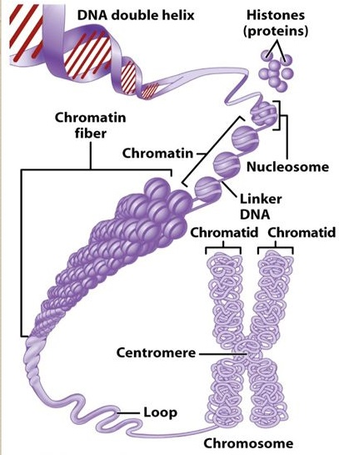  http://images.slideplayer.com/38/10791695/slides/slide_3.jpg

Question 10a asks students “Do the two sister chromatids have the same genes?” In question 10b, students are expected to explain that the two sister chromatids are produced by DNA replication, so they are genetically identical. It should be mentioned that sometimes there are mistakes in replicating the DNA and in some cases the daughter cells are not entirely genetically identical, so human bodies typically have some minor mosaicism (https://www.nytimes.com/2018/05/21/science/mosaicism-dna-genome-cancer.html).

Students often have difficulty understanding the difference between chromosomes and chromatids, so we have made a special effort to clarify this distinction in questions 11b-12. It may help your students if you mention that there is no such thing as a single chromatid without a sister chromatid; once the chromatids have separated, they have become independent chromosomes.

After question 11, we recommend that you show one or more of the following videos:
- A Great Mitosis Video (https://www.youtube.com/watch?v=AhgRhXl7w_g or https://www.youtube.com/watch?v=VlN7K1-9QB0; 1.5 minutes)
- Actual Footage of Cell Division (Kidney Cells) (https://www.youtube.com/watch?v=N97cgUqV0Cg; 1 minute)
- Mitosis (https://www.youtube.com/watch?v=C6hn3sA0ip0; ~6 minutes).
The last video will be particularly appropriate if you want your students to learn the phases of mitosis. If you want your students to learn the names of the phases of mitosis, these terms can easily be incorporated in question 12.
The Student Handout shows cytokinesis in animal cells. Cytokinesis in plant cells is illustrated in this figure. | 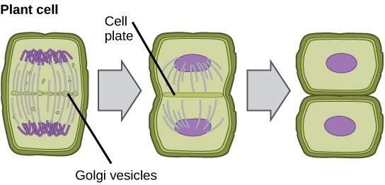  http://cnx.org/resources/7c37e6164130acd4023480c18ba926e8/  Figure_10_02_04.jpg

How Repeated Cell Division Can Make Trillions of Cells
Questions 15-16 help students to understand how a process that adds only one cell each time a cell divides can produce a newborn baby’s 1-4 trillion cells in just nine months. The model implied in these questions is relatively realistic for the first four days, but after that it is only representative of the potential for exponential growth in number of cells. Although the model presented in questions 15-16 is not a realistic description of embryonic and fetal development, it does demonstrate how mitosis can produce trillions of cells from a single cell in just nine months.

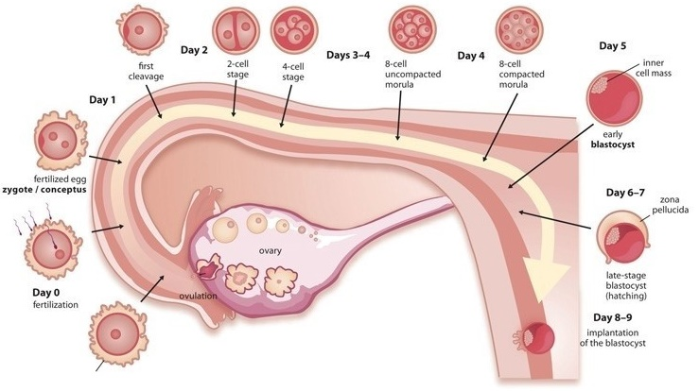
(https://rockthebabybump.com/wp-content/uploads/2015/10/blastocyst-transfer.jpg)

To answer question 16a, your students should recognize that they need to multiply 1000×1000. To answer question 16b, they should calculate:
10³ x 10³ x 10³ x 10³ = 10¹² = 1,000,000,000,000 = 1 trillion cells

You may want to introduce the term, exponential growth, and explain the relevance of exponential growth for other topics such as population growth (see “Understanding and Predicting Changes in Population Size – Exponential and Logistic Population Growth Models vs. Complex Reality”, available at https://serendipstudio.org/exchange/bioactivities/pop).

Question 17 in the Student Handout engages students in synthesizing and summarizing what they have learned about the cell cycle, mitosis, and how a single cell develops into the trillions of genetically identical cells in a human body. This question can be used for formative assessment. If this question is too challenging for your students, you can provide scaffolding as follows.
- If your students have trouble learning vocabulary, you may want to precede question 17 with a question that asks for definitions of the terms listed (or perhaps a matching question in which you provide your preferred definitions for these terms).
- You may want to provide your students with the “Possible Handout to Provide Scaffolding to Help Students Answer Question 17” shown on the last page of these Teacher Notes.
- You can suggest to your students, “Cross off each term in the list in question 17 after you have included the term in your answer.”
- Students may benefit from a preliminary small group discussion of this question. However, each student should prepare a written answer in his or her own words.

To consolidate student learning and correct any misunderstandings your students may have, we recommend a whole-class discussion of student answers to question 17. To facilitate this discussion, you may want to require your students to use diagrams in their answers to question 17 and have pairs or small groups of students prepare their answers on whiteboards. For information about how to make inexpensive whiteboards and use them in your teaching, see "The $2 interactive whiteboard" and "Resources for whiteboarding" in https://fnoschese.wordpress.com/2010/08/06/the-2-interactive-whiteboard/.

Question 18 engages students in thinking about the need for cell division even in a fully grown adult. The rate of cell replacement by mitosis varies for different types of cells and in different circumstances. The rate is greater when an injury has occurred. Cells that are routinely exposed to injury (e.g. skin cells or the epithelial cells that line the lumen of the stomach) are replaced within days or a couple of weeks. In contrast, nerve cells and muscle cells can last a lifetime.

You may want to conclude this section with a class discussion of the Crosscutting Concept, Systems and System Models. For example, you may want to include a discussion of how the quantitative modeling in questions 15-16 helped them to understand how a process that adds only one cell each time a cell divides can produce roughly one trillion cells in nine months.

Cell Differentiation
This section introduces the concept of multiple different types of cells which have different types of proteins to support their different functions. In discussing question 19, you may want to mention the different levels of organization shown in the figure, i.e., cells, tissues and organs.

Each type of cell has a complete set of genes, but in each type of cell only certain genes are turned on for protein production. In the final stages of red blood cell differentiation, the nucleus is ejected. Fully differentiated skin cells also lack a nucleus. This is the reason why question 20 refers to "Cell that is differentiating to become a" red blood cell or skin cell. For simplicity, the Student Handout does not mention the multiple genes that code for different types of hemoglobin or keratin proteins. If you want your students to understand some of the molecular biology of cell differentiation, we recommend “Cell Differentiation and Epigenetics” (https://serendipstudio.org/exchange/bioactivities/epigenetics).

Follow-up and Related Activities
We recommend that you follow this mitosis activity with “Understanding How Genes Are Inherited via Meiosis and Fertilization” (https://serendipstudio.org/exchange/bioactivities/meiosisRR). In this minds-on activity, students answer analysis and discussion questions to learn how a child inherits one copy of each gene from each parent via the processes of meiosis and fertilization. They analyze how the processes of meiosis and fertilization result in the alternation between diploid and haploid cells in the human lifecycle. To learn how meiosis produces genetically diverse gametes, students analyze the results of crossing over and independent assortment. Then, students follow the alleles of a human gene from the parents' body cells through gametes and zygote to a child’s cells. They learn how the outcomes of meiosis and fertilization can be represented in a Punnett square. A brief final section contrasts sexual reproduction with asexual reproduction.

These activities are part of an integrated sequence of learning activities for teaching genetics ("Genetics – Major Concepts and Learning Activities"; available at https://serendipstudio.org/exchange/bioactivities/GeneticsConcepts)

"Chromonoodles: Jump into the Gene Pool" by Farrar and Barnhart, The Science Teacher, Summer 2011, 78:34-39 presents an informative series of activities using chromonoodles (made from swim noodles) to demonstrate fertilization, the cell cycle, meiosis, karyotyping and genetics concepts, including Punnett squares. These activities are whole class demonstrations, in contrast to the more structured modeling activities for small groups of students presented in the Student Handouts for our activities. Additional suggestions for the use of chromonoodles are provided in “Using Pool Noodles to Teach Mitosis and Meiosis”, Genetics 2005, 170(1): 5-6.

Additional resources that you may find helpful are provided in the podcasts available at http://www.bozemanscience.com/028-cell-cycle-mitosis-and-meiosis/.

Sources for Figures in the Student Handout
- First figure on page 1 modified from http://media1.britannica.com/eb-media/16/166816-004-5EA0F269.jpg
- Second figure on page 1 and figure on page 2 modified from https://www2.le.ac.uk/projects/vgec/diagrams/22-Cell-cycle.gif
- First figure on page 3 modified from https://dr282zn36sxxg.cloudfront.net/datastreams/f-d%3A878df64c63462553305d51d5deccdec3c0cb0aee48fa51aeb9297f1b%2BIMAGE_THUMB_POSTCARD_TINY%2BIMAGE_THUMB_POSTCARD_TINY.1
- Second figure on page 3 modified from https://www.researchgate.net/profile/Kevin_Verstrepen/publication/51196608/figure/fig1/AS:276923784679429@1443035183356/Chromatin-structure-DNA-is-wrapped-around-a-histone-octamer-to-form-nucleosomes.png
- Figures on pages 4 and 6 adapted from Krogh, Biology – A Guide to the Natural World

Possible Handout to Provide Scaffolding to Help Students Answer Question 17

Label this diagram to explain how one cell becomes two genetically identical daughter cells.

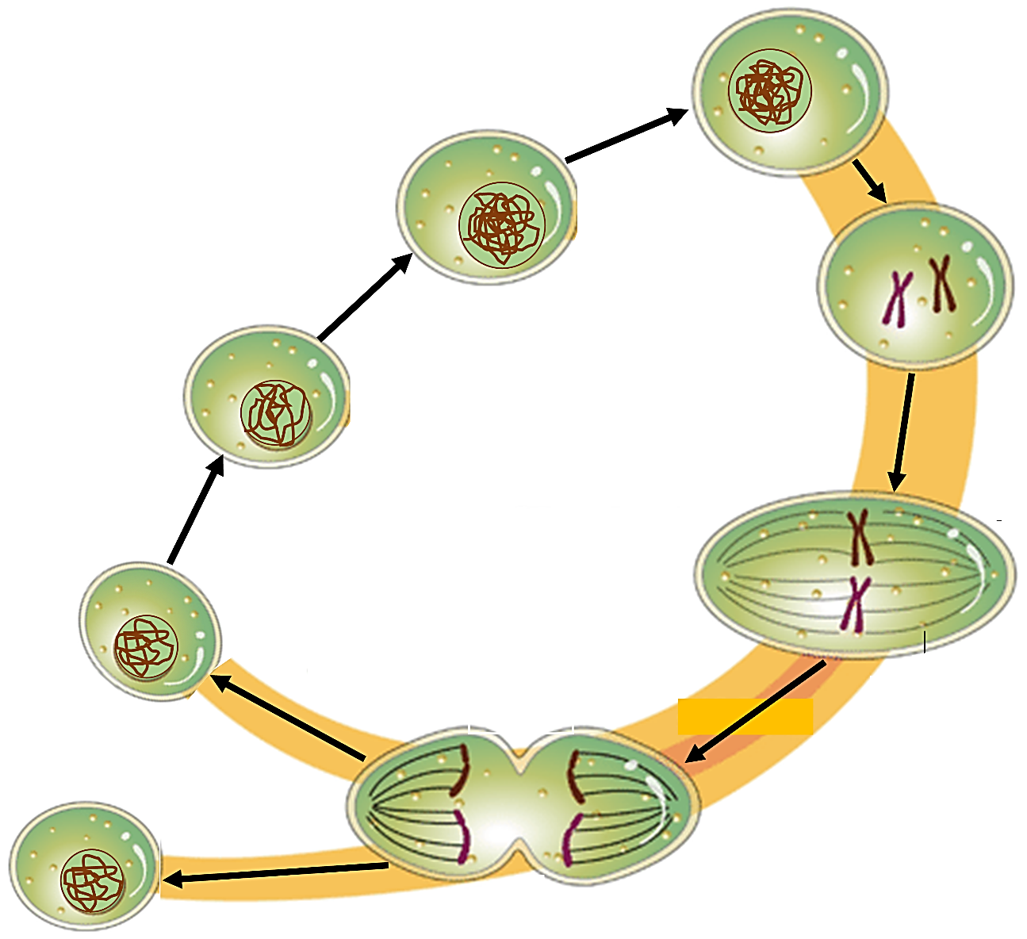

Explain how a single cell becomes more than a trillion cells in nine months.

By Drs. Ingrid Waldron, Jennifer Doherty, Scott Poethig and Lori Spindler, Department of Biology, University of Pennsylvania, 2022. These Teacher Notes and the Student Handout are available at https://serendipstudio.org/exchange/bioactivities/MitosisRR.
Quotations from http://www.nextgenscience.org/sites/default/files/HS%20LS%20topics%20combined%206.13.13.pdf
To draw a shape - At the top of the page, find and click Shape. - Choose the shape you want to use. - Click and drag on the canvas to draw your shape. To insert text - At the top of the page, click Insert. - To place text inside a box or confined area, click Text Box and drag it to where you want it. - Type your text. - You can select, resize and format the word art or text box, or apply styles like bold or italics to the text. When you are done, click Save and Close.
https://education.asu.edu/sites/default/files/the_role_of_collaborative_interactions_versus_individual_construction_on_students_learning_of_engineering_concepts.pdf
A chromosome contains not only a DNA molecule, but also proteins (e.g., histones; see figure on page 5 of these Teacher Notes).
Mammalian red blood cells have no nucleus or mitochondria which maximizes the amount of hemoglobin and thus oxygen that each red blood cell transports. In consequence, red blood cells only survive about four months and red blood cells cannot undergo mitosis; new red blood cells are produced by mitosis and differentiation of stem cells in the bone marrow.
Chromatin structure changes as the molecular activity in the cell changes. For example, when a gene becomes active, the chromatin typically unwinds.
The exponential growth model also ignores the important roles of cell differentiation, cell death, and morphogenesis in development. Cell differentiation is briefly introduced in the last section of this activity. A brief introduction to cell differentiation and morphogenesis in the development of embryos is available at http://www.biology-pages.info/E/EmbryonicDevelopment.html.
Some additional tips for using whiteboards are: – Coat the white boards with Endust (or similar product) before using. Every once in a while, wipe them clean and reapply Endust. – Do not use markers that are old or almost empty, since the ink from these is more difficult to erase. Black markers erase easiest. For effective erasing, it's best to erase the white boards immediately after use. – Teacher and/or students can take a picture of the information on the whiteboard if they want to save it.
Differentiated blood cells and epithelial skin cells are replaced by stem cells; each stem cell divides to form one daughter cell that remains a stem cell and a second daughter cell that differentiates. Some other types of differentiated cells (e.g., skin fibroblasts, liver cells, and smooth muscle cells) can divide to replace cells that have been injured or died. Other types of differentiated cells (e.g., cardiac muscle cells) cannot divide and are not replaced if they die (https://www.ncbi.nlm.nih.gov/books/NBK9906/#:~:text=A%20few%20types%20of%20differentiated,of%20turnover%20in%20adult%20animals.).
A model is a simplified representation of reality that highlights certain key aspects of a phenomenon and thus helps us to better understand and visualize the phenomenon. Many students tend to think of a model as a physical object and may not understand how a figure or quantitative model can be considered a model. It may be helpful to introduce the idea of a conceptual model and give examples of conceptual models that students may have used, e.g a map, a diagram of a football play, and an outline for an essay a student is writing.

